* Math Magic
* Caboose Express
* Learning Patterns
* Ilearnwithboing
* Math is fun
* Itsy Bitzy
* Dino teach- Preschool math
* Learn Shapes
* Math Pre-Kindergarten
* Pre-K Skills :Math, Shapes, color, counting and more

Technology Resources

Isle of Hope

Kindergarten

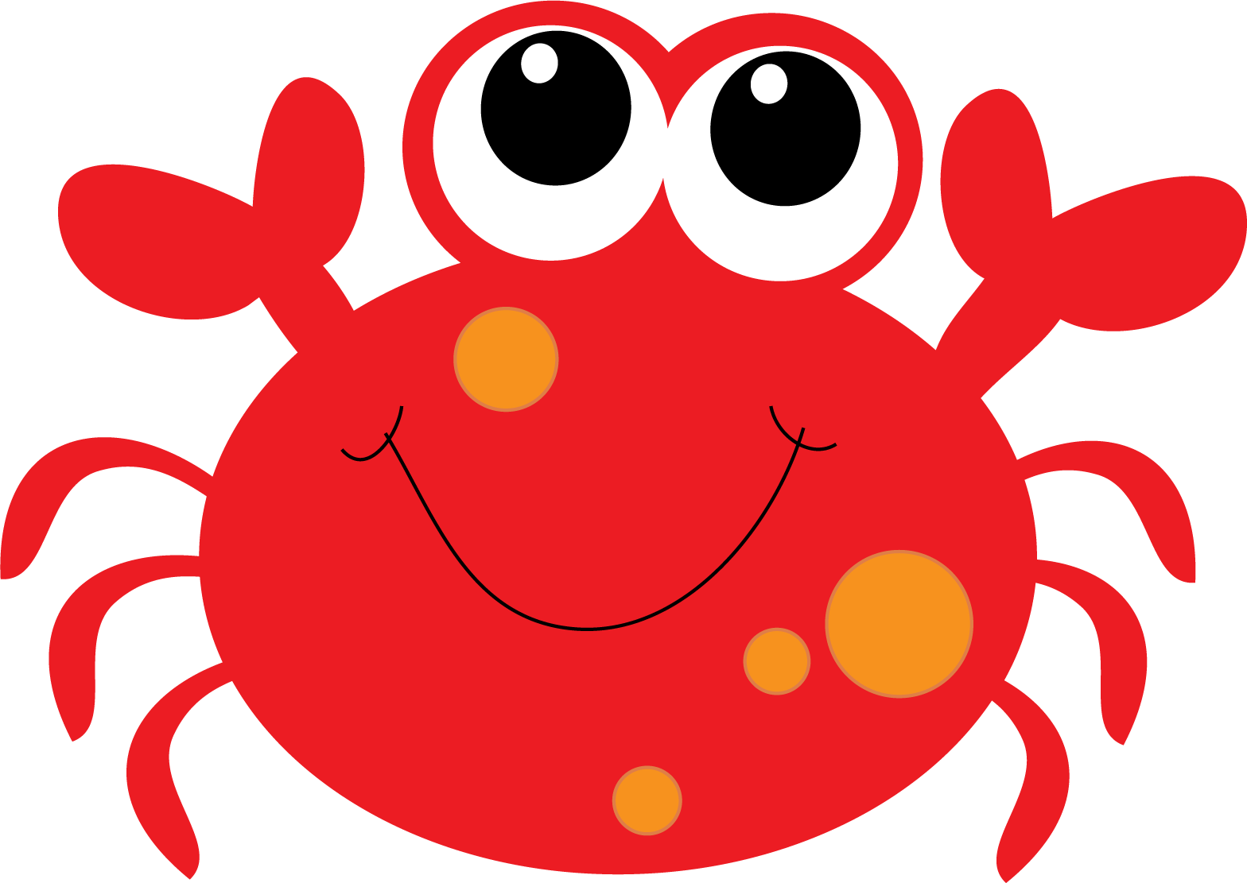

*Kindergarten Websites and Apps*

**

*We hope you find these websites and apps helpful and fun for your little Fiddler!*

Questions- Please Contact:

Bernadette Donner- Kindergarten

Bernadette.Donner@sccpss.com

Barbara Coleman- Kindergarten

Barbara.Coleman@sccpss.com

Debbi Bolta- Kindergarten

Debbi.Bolta@sccpss.com

Karen Robinson – Kindergarten Tricia.Barkee@sccpsss.com

#### Math Apps

* Bobs books
* Gopher Find- Sight words
* ABC Magic
* I like books
* Kids learning
* Kids School
* ABC Ninja
* Reader Rabbit

**Apps for Reading and Phonics**

**Apps for Reading and Phonics**

* Puppet Pals
* Traceable letters
* Kids Academy
* ABC Mouse

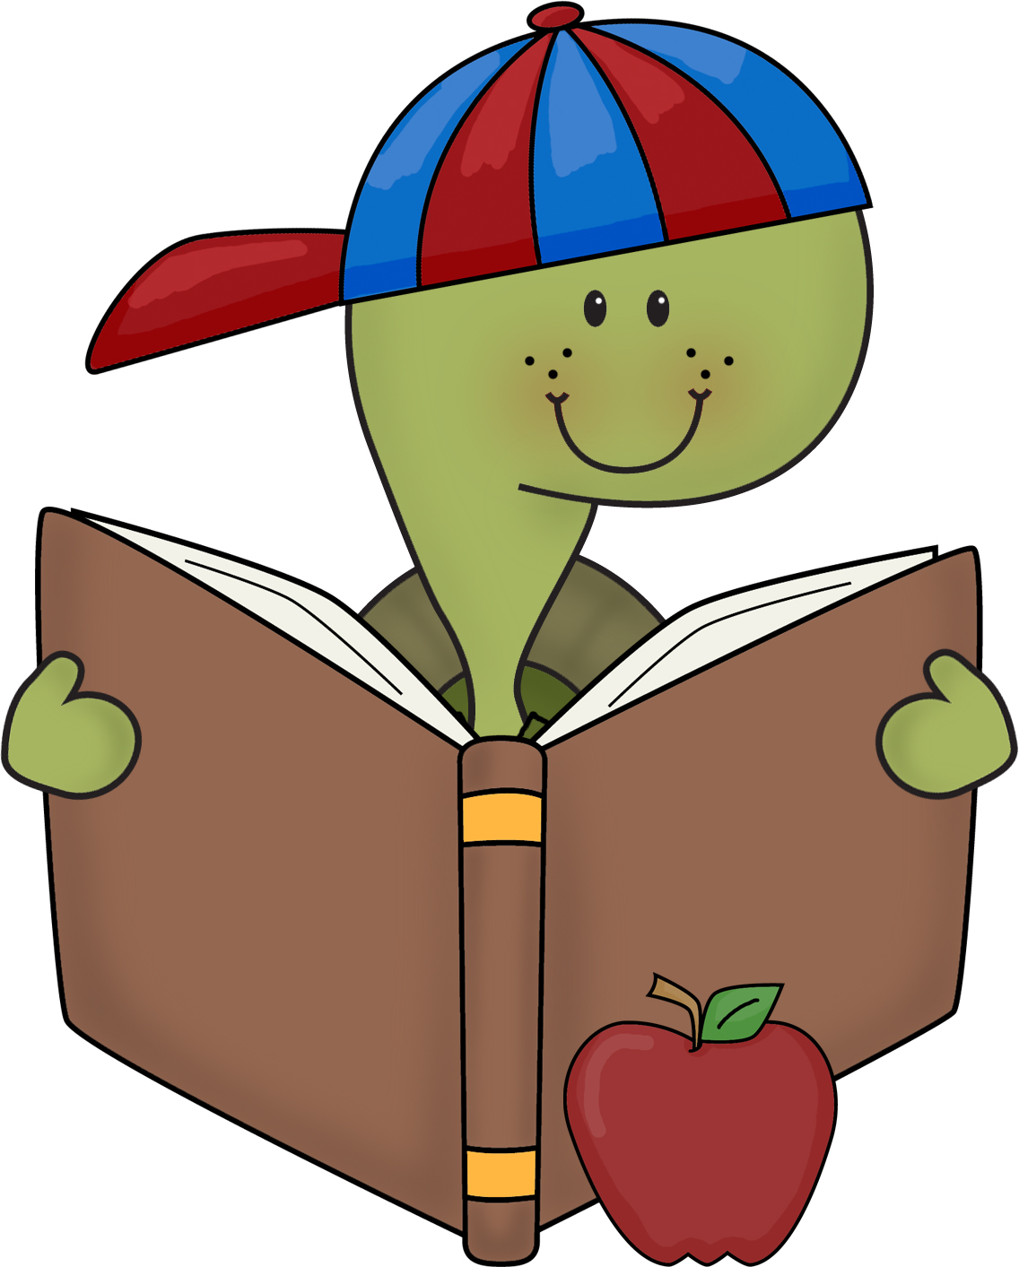

* **Starfall**

http://www.starfall.com/

* **Starfall- Math**

To access math, additional grades click on more on starfall.com or http://more.starfall.com

* **ABC-YA**

http://www.abcya.com/

* **PBS Kids**

http://pbskids.org/games

* **Scholastic**

http://www.scholastic.com

* **IXL**

http://www.ixl.com/

* **HBSchool**

http://www.hbschool.com

* **Have Fun Teaching**

http://www.havefunteaching.com/

.

**Websites for Reading, Phonics and Math**

#### Websites and apps